**Lab100 Knowledge Base**

**Summary** **2**

**Packages** **2**

**Code** **Explanation** **2**

**Devices** **3**

**Data Explanation:** **4**

NHANES: 4

Vitals: 4

3D Body Surface Scan: 8

Body Composition: 10

Cognition: 13

Dexterity: 15

Body Symmetry: 17

Physical Activity: 17

Sleep: 17

Mental Health: 17

Nutrition: 18

## 

# Summary

The Lab100 KB is where any derived data for a patient is calculated, and where all population distribution data is generated. This is done by running a gunicorn webserver on an Amazon cloud server, which does not store any patient data, and can be queried by the Lab100 NodeJS server. It then processes the query, and returns all the data Lab100 needs to display for the patient consult.

# Packages

The KB is coded in python. It uses Flask for its web architecture. It uses Numpy, Scipy, and ScikitLearn to perform various tasks.

# Code Explanation

The KB is utilized via API calls, which generally are either 1) a query for cohort data and stats relative to basic patient demographics and a single patient value, or 2) they’re a post to submit a JSON with raw patient data in order to get derived patient data.

An explanation of the files, file structure, and API calls can be found [here](https://docs.google.com/document/d/1EzeDIWRDnbKNb_h_sxjA1bmemjS745MnbjPXBlNWg6Y/edit?usp=sharing).

## 

# Devices

[Piccolo](https://www.medline.com/product/Abbott-Piccolo-Xpress-Analyzer/Z05-PF105442) - A device for analyzing blood

[Fit3d](https://fit3d.com/) - A full body scanner that measures anthropometric data.

[InBody](https://inbodyusa.com/) - A tool for measuring body composition and weight

[NIH Toolbox](http://www.healthmeasures.net/explore-measurement-systems/nih-toolbox) - A battery of tests that evaluate cognitive and motor performance.

[Welch Allyn Connex Spot Monitor](https://www.welchallyn.com/content/dam/welchallyn/documents/sap-documents/LIT/80019/80019224LITPDF.pdf) - A tool for measuring vitals

[Jamar Hydraulic Hand Dynometer](https://www.performancehealth.com/jamar-hydraulic-hand-dynamometer) - A tool for measuring grip strength in accordance with NIH toolbox

Surveys - We administer several surveys to measure [physical activity levels](https://snaped.fns.usda.gov/library/materials/international-physical-activity-questionnaire-ipaq), [sleep quality,](https://www.ncbi.nlm.nih.gov/pubmed/2748771) [mental health](https://www.ncbi.nlm.nih.gov/pmc/articles/PMC1495268/), and [nutrition](https://www.cdc.gov/nchs/nhanes/index.htm).

# Data Explanation:

### NHANES:

The National Health and Nutrition Examination Survey is a survey done every year by the CDC to collect population health statistics on the country. It is publicly available, and was used to generate population data for a number of metrics so that subjects can see how they compare to others (with matching demographic data, see [here](https://docs.google.com/document/d/1R-YbjQ9vpBTzKHhUzlkf-CWohusP8yCCurKS441mPug/edit?usp=sharing)).

Note that NHANES is not a perfect sample - while we can match gender, age, and ethnicity, we are not matching education or social status, which can contribute significantly to certain population metrics. In the future, we would like to generate population distribution statistics using data more representative of the patient population.

### Vitals:

* **Blood Pressure**
  + Resource: [JNC8 2017 Guidelines](https://healthmetrics.heart.org/highlights-from-the-2017-guideline/)
  + Justification: Routine
  + Validation:
  + Age/Gender Specific: No
  + Population: None
  + Reference Range:

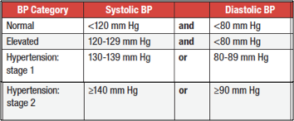

* **Heart Rate**
  + Resource: [Resting heart rate chart](http://www.topendsports.com/testing/heart-rate-resting-chart.htm)1 [or chart 2](https://www.belmarrahealth.com/resting-heart-rate-chart-factors-influence-heart-rate-elderly/)
  + Justification: Routine
  + Age/Gender Specific: No
  + Population: None
  + Reference Range

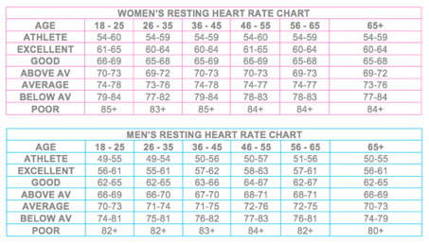

* **Temperature**
  + Resource: [NLM medlinePlus Body Temp norms](https://medlineplus.gov/ency/article/001982.htm) and [Hypothermia](https://medlineplus.gov/hypothermia.html)
  + Justification: Routine
  + Age/Gender Specific: No
  + Population: None
  + Reference Range:
    - <95, Hypothermia;
    - 95 to 97, Low;
    - 97 to 99, Normal;
    - 99 to 100.4, Elevated;
    - >100.4, Fever
* **Oxygen Saturation**
  + Resource: [NLM MedlinePlus SaO2 norms](https://medlineplus.gov/ency/article/003855.htm)
  + Justification: Routine
  + Age/Gender Specific: No
  + Population: None
  + Reference Range:
    - <94, Low;
    - 94-100, Normal

**Blood Draw:**

* **Comprehensive metabolic panel: Electrolytes (E), Kidney Function (K), Metabolism (M), and Liver Function (L) (Total 15)**
  + Resource: [Piccolo White Paper Comprehensive Metabolic Table 4](https://www.abaxis.com/sites/default/files/resource-packages/Comprehensive%20Metabolic%20Panel%20Package%20Insert-EN_0.pdf)
  + Justification: Important measures of metabolic health
  + Measurement: Piccolo
  + Age/Gender specific: None except for ALP with gender specific
  + Population: None (NHANES available, but not displayed)
  + Reference range:

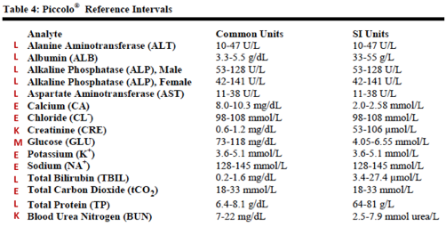

* **Lipid Panel**
  + Resource: [Piccolo White Paper Lipid Panel Table 4](https://www.abaxis.com/sites/default/files/resource-packages/Lipid%20Panel%20Package%20Insert-EN_0.pdf)
  + Justification: Important measures of metabolic health
  + Measurement: Piccolo
  + Age/Gender specific: None except for Cholesterol/HDLratio with gender specific
  + Population: None (NHANES available, but not displayed)

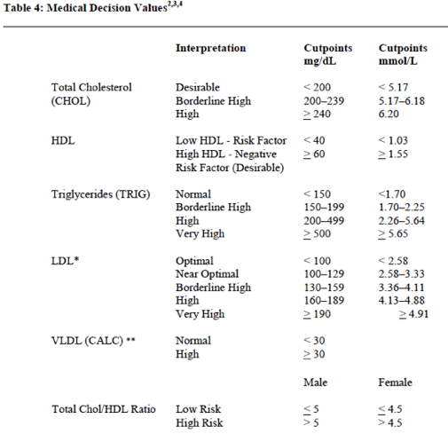

### 

### 3D Body Surface Scan:

* **Waist Circumference, ABSI**
  + Resource: [PLOS ONE paper 2012](https://journals.plos.org/plosone/article?id=10.1371/journal.pone.0039504)
  + Justification: ABSI and Waist Circumference are important predictors of cardiovascular and other health conditions.
  + Measurement: Fit3D Scanner
  + Age/Gender Specific: Yes
  + Population: NHANES
  + Reference: PLOS ONE [Paper 2013](http://journals.plos.org/plosone/article/file?id=10.1371/journal.pone.0068716&type=printable)

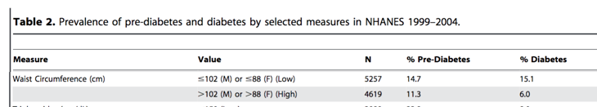

* + Calculation:



* **Trunk to Leg Volume Ratio**
  + Resource: [PLOS ONE Paper 2013](https://journals.plos.org/plosone/article?id=10.1371%2Fjournal.pone.0068716)
  + Justification: Trunk to Leg Volume ratio is highly predictive of diabetes, as well as other conditions, included all causes mortality and cardiovascular health.
  + Measurement: Fit3D Scanner
  + Age/Gender Specific: Yes
  + Population: Literature on PLOS ONE [Paper 2013](http://journals.plos.org/plosone/article/file?id=10.1371/journal.pone.0068716&type=printable)
  + Reference: Quartiles from PLOS ONE paper
* **SBSI**
  + Resource: [PLOS ONE Paper 2015](https://journals.plos.org/plosone/article?id=10.1371/journal.pone.0144639)
  + Justification: SBSI is highly predictive of all causes mortality, and serves as a replacement for BMI.
  + Measurement: Fit3D Scanner
  + Age/Gender Specific: No
  + Population: Mean, SD from literature on PLOS ONE [Paper 2015](http://journals.plos.org/plosone/article/file?id=10.1371/journal.pone.0144639&type=printable), which is based on NHANES dataset.
  + Reference: None
  + Calculation:



* **Waist to Hip Ratio**
  + Resource: [ACSM's Resources for the Health Fitness Specialist 2014 book version](https://books.google.com/books?id=VFJht0r-I4cC&lpg=PA145&ots=2uLo7qustR&dq=cooper%20institute%20fitness%20category%20for%20body%20composition&pg=PA146#v=onepage&q&f=false)
  + Justification: Associated with diabetes, all cause mortality, cardiovascular disease
  + Measurement: Fit3D Scanner
  + Age/Gender Specific: Yes
  + Population Data: Mean, SD from Fit3D
  + Reference:  
    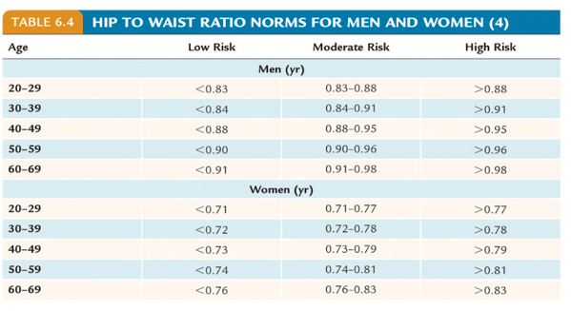

### 

### Body Composition:

* **Body Fat Mass**
  + Resource: [ACSM's Health-Related Physical Fitness Assessment Manual](https://www.evernote.com/l/AAockVn2BRJJVbosdY_Qfh7oa75lkxzWwn0)
  + Justification: Cardiovascular Health.
  + Measurement: Inbody
  + Age/Gender Specific: Yes
  + Population: NHANES
  + Reference:   
    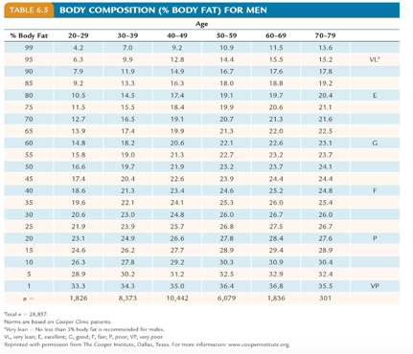

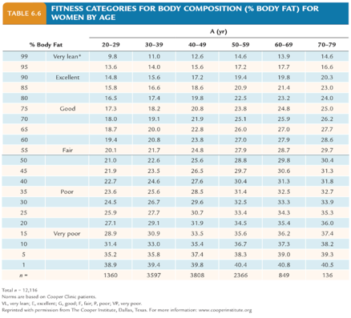

* **Skeletal Muscle Mass**
  + Resource: [JAP paper 2000](https://www.physiology.org/doi/pdf/10.1152/jappl.2000.89.1.81)
  + Justification: Cardiovascular Health.
  + Measurement: Inbody
  + Age/Gender Specific: Yes
  + Population:   
    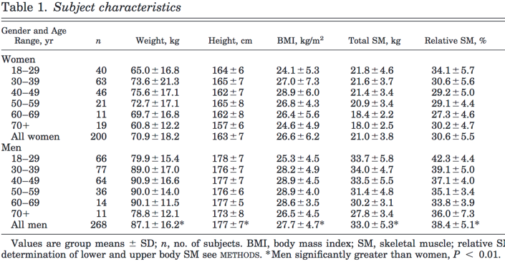
  + Reference: NA
* **Visceral Fat Mass**
  + Resource: [PLOS One 2017](https://www.ncbi.nlm.nih.gov/pmc/articles/PMC5500349/pdf/pone.0180614.pdf)
  + Justification: Cardiovascular Health.
  + Measurement: Inbody
  + Age/Gender Specific: Yes
  + Population: No
  + Reference:
    - >= 10 : High Risk
    - < 10: Low Risk

### 

### Cognition:

* **Vocabulary**
  + Resource: [NIH Toolbox](http://www.healthmeasures.net/explore-measurement-systems/nih-toolbox/intro-to-nih-toolbox/cognition)
  + Justification: Measurement of mental capability
  + Measurement: Picture Vocabulary Test
  + Age/Gender specific: No
  + Population: Using psychometric score interpretation T-score outputted by [NIH Toolbox app](http://www.healthmeasures.net/explore-measurement-systems/nih-toolbox/intro-to-nih-toolbox/cognition) is converted to percentile (mean = 50, SD = 10)
  + Reference: [Psychometric Conversion Table](https://www.ritenour.k12.mo.us/cms/lib/MO01910124/Centricity/Domain/69/Psychometric_Conversion_Table.pdf)
* **Attention**
  + Resource: [NIH Toolbox](http://www.healthmeasures.net/explore-measurement-systems/nih-toolbox/intro-to-nih-toolbox/cognition)
  + Justification: Measurement of mental capability
  + Measurement: Flanker Inhibitory Control and Attention Test
  + Age/Gender specific: No
  + Population: Using psychometric score interpretation T-score outputted by [NIH Toolbox app](http://www.healthmeasures.net/explore-measurement-systems/nih-toolbox/intro-to-nih-toolbox/cognition) is converted to percentile (mean = 50, SD = 10)
  + Reference: [Psychometric Conversion Table](https://www.ritenour.k12.mo.us/cms/lib/MO01910124/Centricity/Domain/69/Psychometric_Conversion_Table.pdf)
* **Flexibility**
  + Resource: [NIH Toolbox](http://www.healthmeasures.net/explore-measurement-systems/nih-toolbox/intro-to-nih-toolbox/cognition)
  + Justification: Measurement of mental capability
  + Measurement: Dimensional Change Card Sort Test
  + Age/Gender specific: No
  + Population: Using psychometric score interpretation T-score outputted by [NIH Toolbox app](http://www.healthmeasures.net/explore-measurement-systems/nih-toolbox/intro-to-nih-toolbox/cognition) is converted to percentile (mean = 50, SD = 10)
  + Reference: [Psychometric Conversion Table](https://www.ritenour.k12.mo.us/cms/lib/MO01910124/Centricity/Domain/69/Psychometric_Conversion_Table.pdf)
* **Processing Speed**
  + Resource: [NIH Toolbox](http://www.healthmeasures.net/explore-measurement-systems/nih-toolbox/intro-to-nih-toolbox/cognition)
  + Justification: Measurement of mental capability
  + Measurement: Pattern Comparison Processing Speed Test
  + Age/Gender specific: No
  + Population: Using psychometric score interpretation T-score outputted by [NIH Toolbox app](http://www.healthmeasures.net/explore-measurement-systems/nih-toolbox/intro-to-nih-toolbox/cognition) is converted to percentile (mean = 50, SD = 10)
  + Reference: [Psychometric Conversion Table](https://www.ritenour.k12.mo.us/cms/lib/MO01910124/Centricity/Domain/69/Psychometric_Conversion_Table.pdf)
* **Episodic Memory**
  + Resource: [NIH Toolbox](http://www.healthmeasures.net/explore-measurement-systems/nih-toolbox/intro-to-nih-toolbox/cognition)
  + Justification: Measurement of mental capability
  + Measurement: Picture Sequence Memory Test
  + Age/Gender specific: No
  + Population: Using psychometric score interpretation T-score outputted by [NIH Toolbox app](http://www.healthmeasures.net/explore-measurement-systems/nih-toolbox/intro-to-nih-toolbox/cognition) is converted to percentile (mean = 50, SD = 10)
  + Reference: [Psychometric Conversion Table](https://www.ritenour.k12.mo.us/cms/lib/MO01910124/Centricity/Domain/69/Psychometric_Conversion_Table.pdf)

### 

### Dexterity:

* **Dominant Hand**
  + Resource: [NIH Toolbox](http://www.healthmeasures.net/explore-measurement-systems/nih-toolbox/intro-to-nih-toolbox/motor)
  + Justification: Deterioration of dexterity is a predictor of cognitive decline
  + Measurement: 9-Hole Pegboard Dexterity Test
  + Age/Gender specific: Yes. Also ethnicity and education.
  + Population: Normalized via calculations from NIH toolbox
  + Reference: [T Value Conversion Table](https://www.ritenour.k12.mo.us/cms/lib/MO01910124/Centricity/Domain/69/Psychometric_Conversion_Table.pdf)
* **Non-Dominant Hand**
  + Resource: [NIH Toolbox](http://www.healthmeasures.net/explore-measurement-systems/nih-toolbox/intro-to-nih-toolbox/motor)
  + Justification: Deterioration of dexterity is a predictor of cognitive decline
  + Measurement: 9-Hole Pegboard Dexterity Test
  + Age/Gender specific: Yes. Also ethnicity and education.
  + Population: Normalized via calculations from NIH toolbox
  + Reference: [T Value Conversion Table](https://www.ritenour.k12.mo.us/cms/lib/MO01910124/Centricity/Domain/69/Psychometric_Conversion_Table.pdf)

**Strength:**

* **Dominant Hand**
  + Resource: [NIH Toolbox](http://www.healthmeasures.net/explore-measurement-systems/nih-toolbox/intro-to-nih-toolbox/motor)
  + Justification: Associated with all cause mortality
  + Measurement: Grip Strength test using [Jamar Hydraulic Hand Dynometer](https://www.performancehealth.com/jamar-hydraulic-hand-dynamometer)
  + Age/Gender specific: Yes. Also ethnicity and education.
  + Population: Normalized via calculations from NIH toolbox
  + Reference: [T Value Conversion Table](https://www.ritenour.k12.mo.us/cms/lib/MO01910124/Centricity/Domain/69/Psychometric_Conversion_Table.pdf)
* **Non-Dominant Hand**
  + Resource: [NIH Toolbox](http://www.healthmeasures.net/explore-measurement-systems/nih-toolbox/intro-to-nih-toolbox/motor)
  + Justification: Associated with all cause mortality
  + Measurement: Grip Strength test using [Jamar Hydraulic Hand Dynometer](https://www.performancehealth.com/jamar-hydraulic-hand-dynamometer)
  + Age/Gender specific: Yes. Also ethnicity and education.
  + Population: Normalized via calculations from NIH toolbox
  + Reference: [T Value Conversion Table](https://www.ritenour.k12.mo.us/cms/lib/MO01910124/Centricity/Domain/69/Psychometric_Conversion_Table.pdf)

**Balance:**

* **Standing Balance Test**
  + Resource: [NIH Toolbox](http://www.healthmeasures.net/explore-measurement-systems/nih-toolbox/intro-to-nih-toolbox/motor)
  + Justification: The sense of balance relies on eyes, ear, and the muscles and touch sensors in your legs. Inbalance indicates several balance disorders including benign paroxysmal positional vertigo, Labyrinthitis, vertigo, vestibular neuronitis, perilymph fistula, Mal de Debarquement syndrome
  + Measurement: Standing Balance Test
  + Age/Gender specific: Yes. Also ethnicity and education.
  + Population: Using psychometric score interpretation T-score outputted by [NIH Toolbox app](http://www.healthmeasures.net/explore-measurement-systems/nih-toolbox/intro-to-nih-toolbox/cognition) is converted to percentile (mean = 50, SD = 10).
  + Reference: [T Value Conversion Table](https://www.ritenour.k12.mo.us/cms/lib/MO01910124/Centricity/Domain/69/Psychometric_Conversion_Table.pdf)
  + Note:Balance performance pie chart needs work

### Body Symmetry:

* **Biceps, Forearm, Thigh, Calf, Lean Mass Arm, Lean Mass Leg, Fat Mass Arm, Fat Mass Arm, Dexterity, Strength (N=10)**
  + Resource:
  + Justification: Symmetry is linked to athletic injury chance / recovery
  + Measurement: Fit3D
  + Equation: Symmetry Index = (Right - Left) / (Right + Left)
  + Age/Gender specific: No
  + Population/normative data: No

### Physical Activity:

* **Moderate, Walking, Vigorous physical activity**
  + Resource: [IPAQ](https://www.ncbi.nlm.nih.gov/pubmed/16925881)
  + Justification: Physical activity is predictive of all causes mortality
  + Measurement: [Self survey by International Physical Activity Questionnaire (IPAQ).](https://docs.google.com/viewer?a=v&pid=sites&srcid=ZGVmYXVsdGRvbWFpbnx0aGVpcGFxfGd4OjUxNjA1MzU5ZDI3NjViNmQ) also [See scoring protocol](https://sites.google.com/site/theipaq/)
  + Age/Gender specific: No
  + Population: None
  + Reference: See Scoring

### Sleep:

* **Sleep duration, Sleep disturbance, Sleep latency, Daytime dysfunction, Sleep efficiency, Sleep quality, Medication requirement** 
  + Resource: [PSQI](https://www.ncbi.nlm.nih.gov/pubmed/2748771)
  + Justification: Sleep quality is associated with cognitive function
  + Measurement: [Self Survey by Sleep Pittsburgh Sleep Quality Index (PSQI)](http://www.sleep.pitt.edu/research/ewExternalFiles/PSQI%20Instrument.pdf). also [see scoring protocol](http://www.sleep.pitt.edu/research/ewExternalFiles/PSQI%20Scoring.doc) (PMID: [2748771](https://www.psy-journal.com/article/0165-1781(89)90047-4/pdf))
  + Age/Gender specific: No
  + Population: None
  + Reference: See Scoring

### Mental Health:

* **Depression**
  + Resource: [PHQ-9](https://www.ncbi.nlm.nih.gov/pmc/articles/PMC1495268/)
  + Justification: Depression is a negative outcome
  + Measurement: [Mental Health Patient Health Questionnaire (PHQ-9)](https://link.springer.com/article/10.1046%2Fj.1525-1497.2001.016009606.x) (Journal of General Internal Medicine, September 2001, Volume 16, Issue 9, pp 606-613). Also see [See scoring protocol](https://www.uspreventiveservicestaskforce.org/Home/GetFileByID/218)
  + Age/Gender specific: No
  + Population: NHANES
  + Reference: See Scoring

### Nutrition:

* + Resource: [NHANES DSQ](https://epi.grants.cancer.gov/nhanes/dietscreen/)
  + Measurement: NHANES DSQ
  + Justification: Nutrition is important to health outcomes
  + Age/Gender Specific: Yes
  + Population: NHANES
  + Reference: No